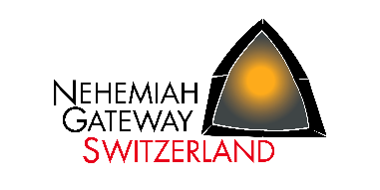
Nehemiah Gateway Switzerland
c.o. Kai & Anne Uellendahl
Untere Bächlen 2
CH-5630 Muri

T +41 (0)56 664 6436
office-ch@ng.team
www.ng.team

Bank Account:
Aargauische Kantonalbank
IBAN CH19 0076 1644 5717 1200 1
BIC: KBAGCH22

Membership Application

Name, first name:
Street:
Postcode/City:
Date of birth:
Phone
private/business/mobile
Email:

I would like to become a member, have read the statutes of the association and
acknowledge them.
I agree to receive information from the association on electronic and postal way.
I agree that my personal data will be stored and processed in a member and contribution file in accordance with the DSG (Bundesgesetz über den Datenschutz/Federal Law on Data Protection). The data will only be used for association purposes. Without this consent, no membership can be established.

Remarks:
_

_______________________________
Place, date Signature

Please send to the above address by mail or email. THANK YOU!

